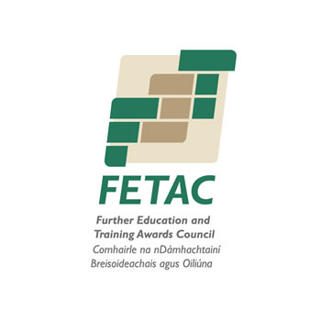

FETAC Level 5
A Palliative Care Approach (D20170)

Commencing 16th April 2013
(8 Tuesday Evenings) 7.00pm – 10.00pm

Date | Content
16/04/13  23/04/13 | Working with A Palliative Care Approach
30/04/13  07/05/13 | Communication Skills
14/05/13  21/05/13 | Death and Dying
28/05/13  04/06/13 | Bereavement Care

The module is designed to equip the learner with the knowledge and skills of the palliative care approach to enable them to care for the person diagnosed with a life-limiting illness and, in the last days of a person’s life and also his/her family in a dignified and holistic way.

Pre-requisites
This course is open to all with general work/life experience. Participants should be in occupational roles sufficient to allow them reflect upon the practical implications of palliative care. It is a suitable course for those with a significant professional interest in areas such as Health Care and Community Care.

This module may be personally demanding on those who have been recently bereaved. Please feel free to contact the Education Centre to explore this further.

Course Aim
This course is designed to provide practical knowledge and skills of the palliative care approach. Specifically participants will be enabled to:

- Provide holistic care for persons diagnosed with a life- limiting illness and in the last days of a person’s life and also for their families, carers and significant others.
- Communicate effectively with persons with a life-limiting illness and in the last days of a person’s life and also with their families, carers and significant others.
- Enhance the quality of life of the person with a life- limiting illness.
- Recognise and respect the uniqueness of each person’s approach to death work effectively as part of the healthcare team.

On successful completion of this course, learners are awarded FETAC Level 5 ‘A Pallative Care Approach’ (D20180).

Assessments: Skills Demonstration (60%) and Project (40%)

Entry Requirements:

- Leaving Certificate or relevant qualifications and/or relevant life and work experiences
- All participants on this course must have good fluency in English

Cost: €325 – booking form and payment required in advance of course commencement. Fee is non-refundable

Location: The Education Centre is located on the Grounds of St. Luke’s Home, Castle Road, Mahon. We are located close to Blackrock Castle and the following link provides directions and map.

http://www.stlukeshome.ie/node/101

Further Information available from: Claire at 021 4536551
Further Details on all the courses provided by the Education Centre are available on www.stlukeshome.ie/education-centre

The Education Centre was opened during 2011 and purpose built to meet the access needs of all learners. Disability Car Parking is available.

Places will be allocated on a first come first served basis and early booking is recommended.

